Dana Kallunki
Nov. 10, 2014
Class work/Homework 4.
- Create user using SQL* Plus
CREATE USER john
IDENTIFIED BY johnpass
DEFAULT TABLESPACE users
TEMPORARY TABLESPACE temp
QUOTA UNLIMITED on users
PROFILE default
PASSWORD EXPIRE
ACCOUNT UNLOCK
/

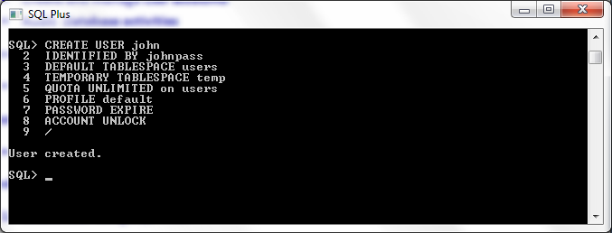

- Change the default tablespace and quota for user
ALTER USER john
DEFAULT TABLESPACE brownie;

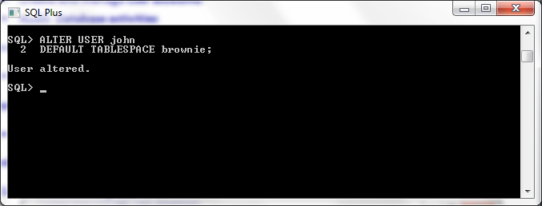

ALTER USER john
QUOTA 50M ON brownie;

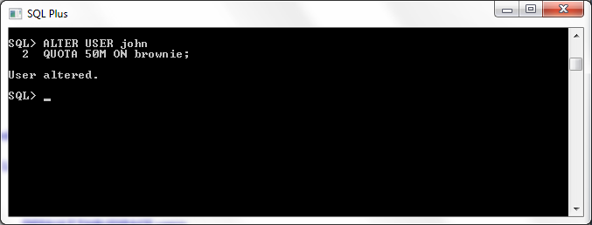

- Grant systems and object privileges
Object Privileges
GRANT SELECT, INSERT, UPDATE, DELETE ON dog to john;
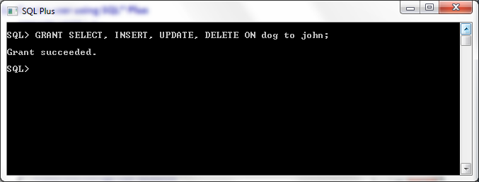
This will allow the user john to manipulate the rows on the table dog.

GRANT ALTER, INDEX ON dog to john;
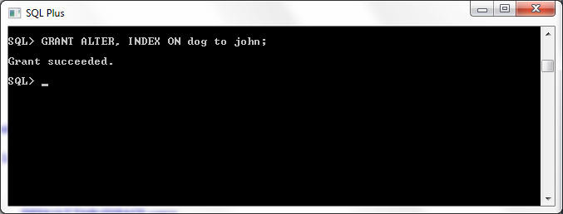
System Privileges
GRANT CREATE ANY TABLE, ALTER ANY TABLE, DROP ANY TABLE TO john;
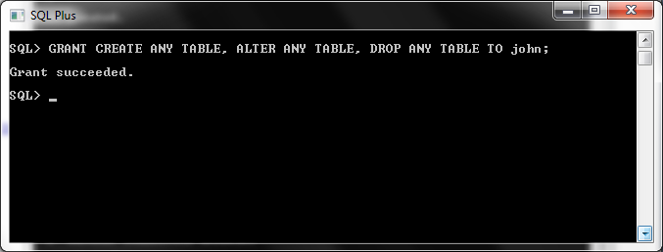

GRANT CREATE ANY SYNONYM, DROP ANY SYNONYM, CREATE TABLESPACE, ALTER TABLESPACE, DROP TABLESPACE, MANAGE TABLESPACE TO john;

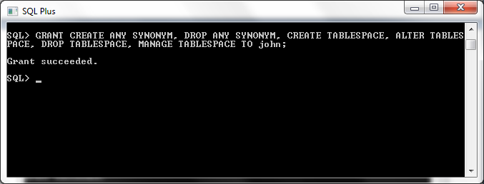

- Use Database Control to create and grant privileges
Selecting user john from the list of users to grant system privileges. 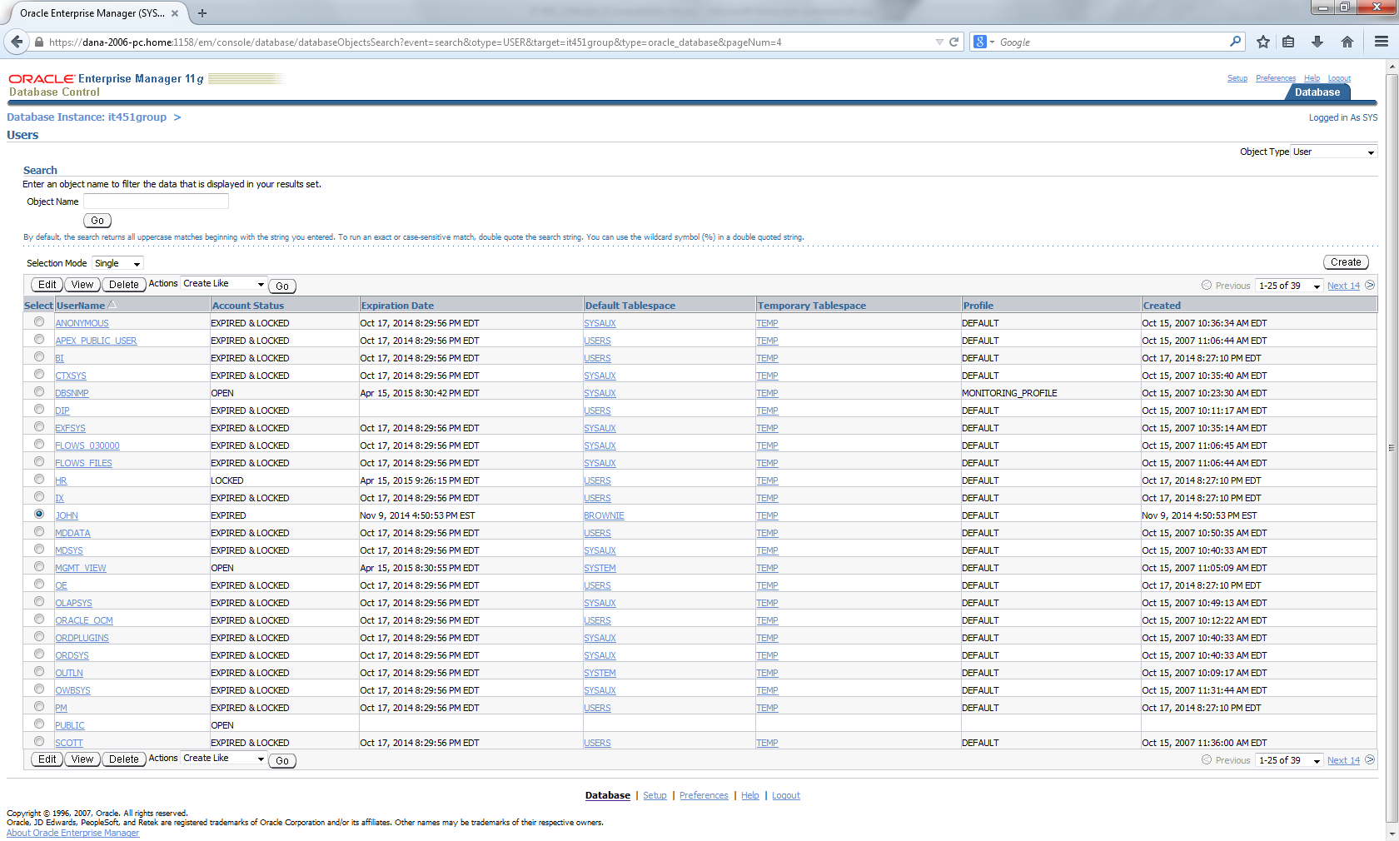

We decided to add the system privileges LOCK ANY TABLE, SELECT ANY TABLE, UPDATE ANY TABLE to the user john.

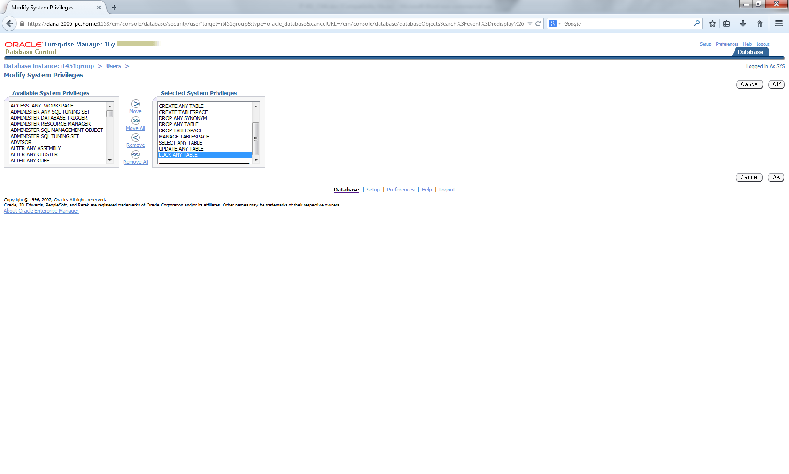

List of new system privileges granted to john.
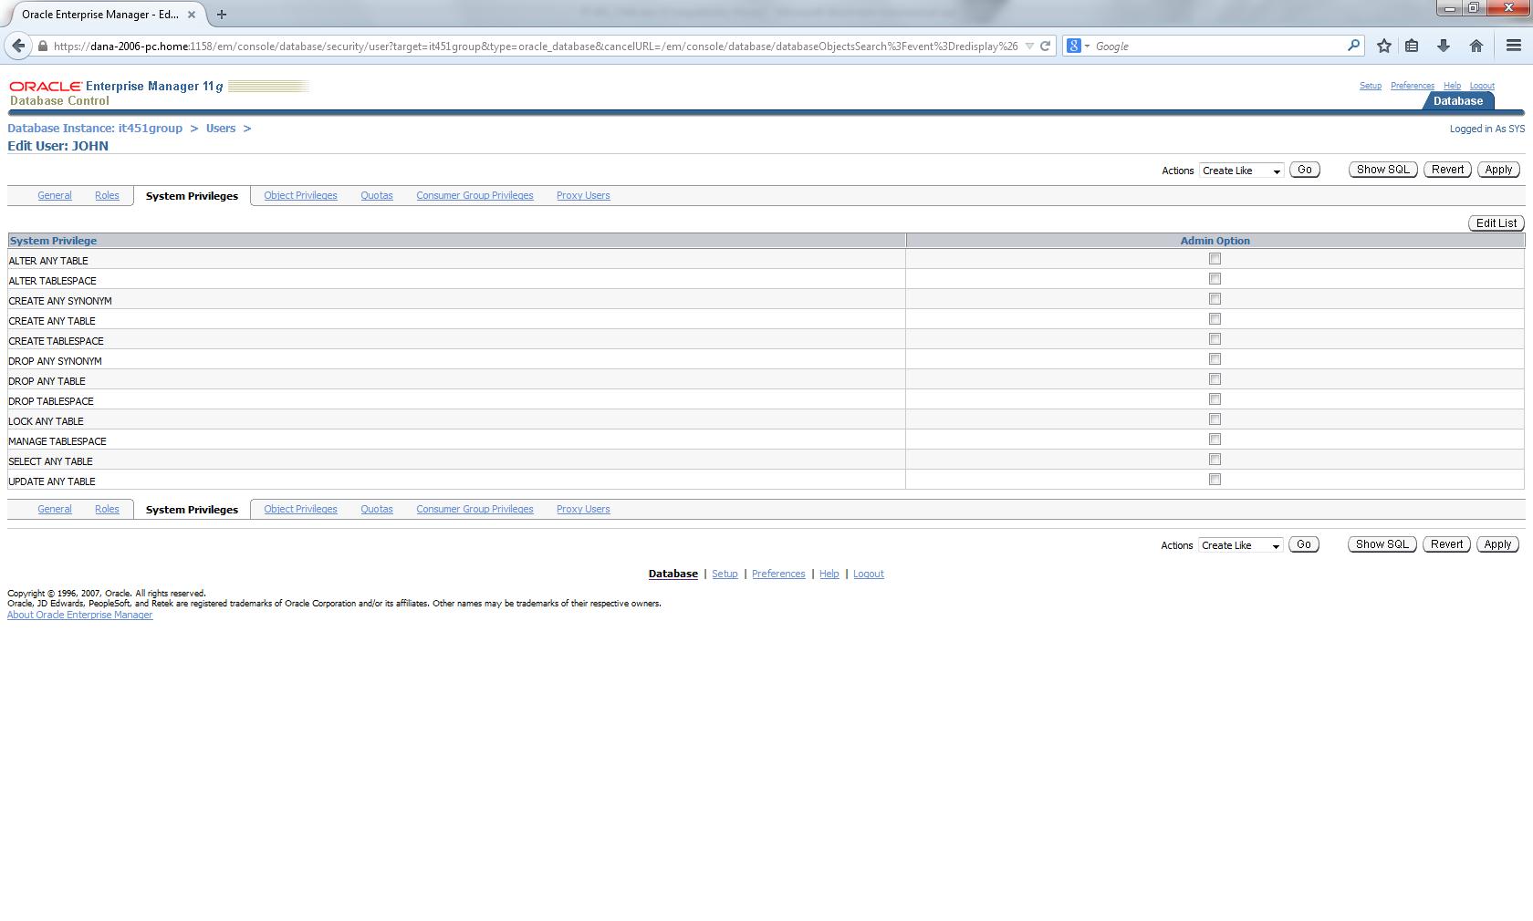

We decided to add the object privilege References to john for the dog table.
We decided to grant a new table privilege to the user john. Added References
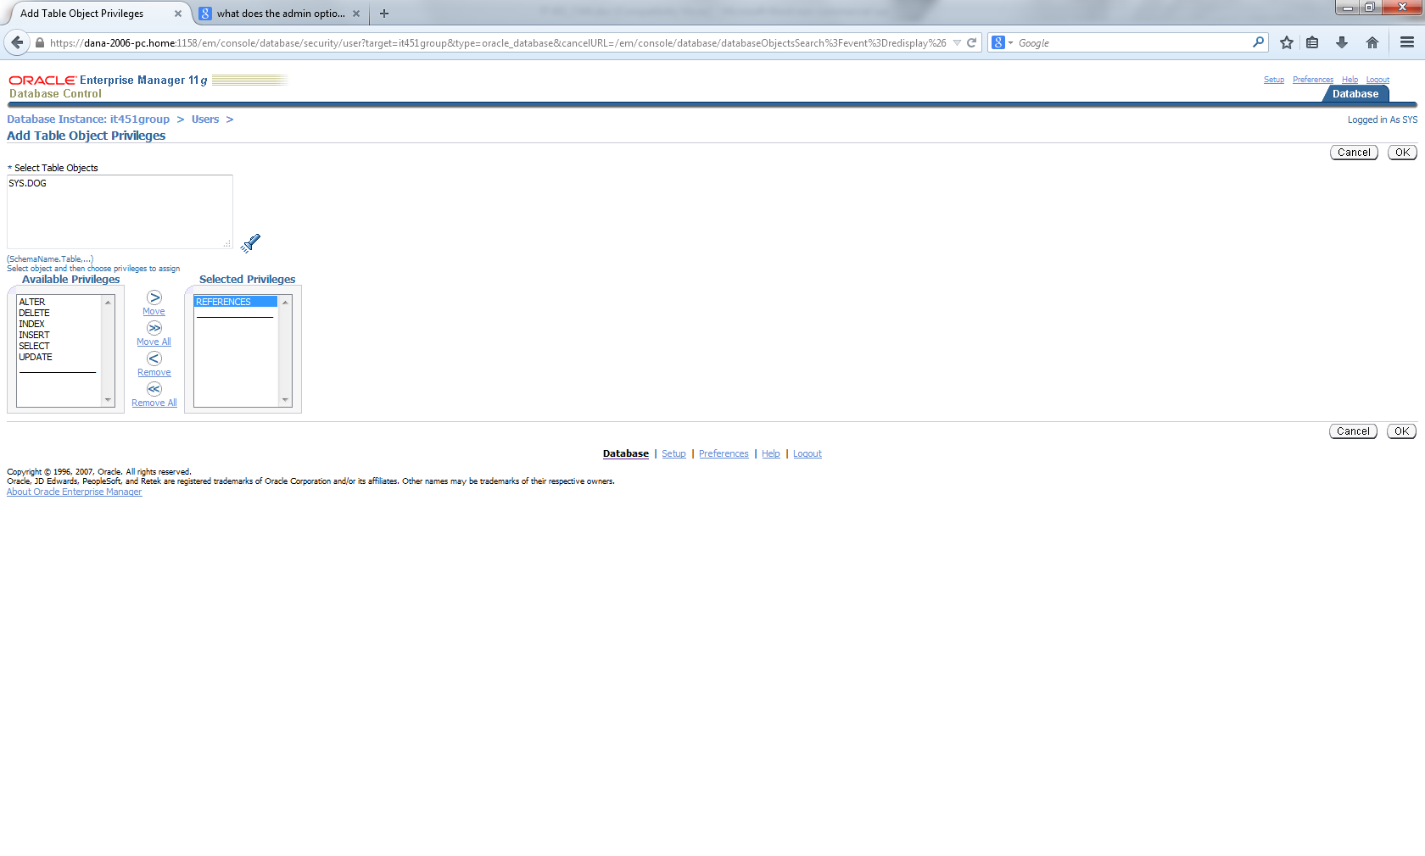

List of new object privileges granted to john.

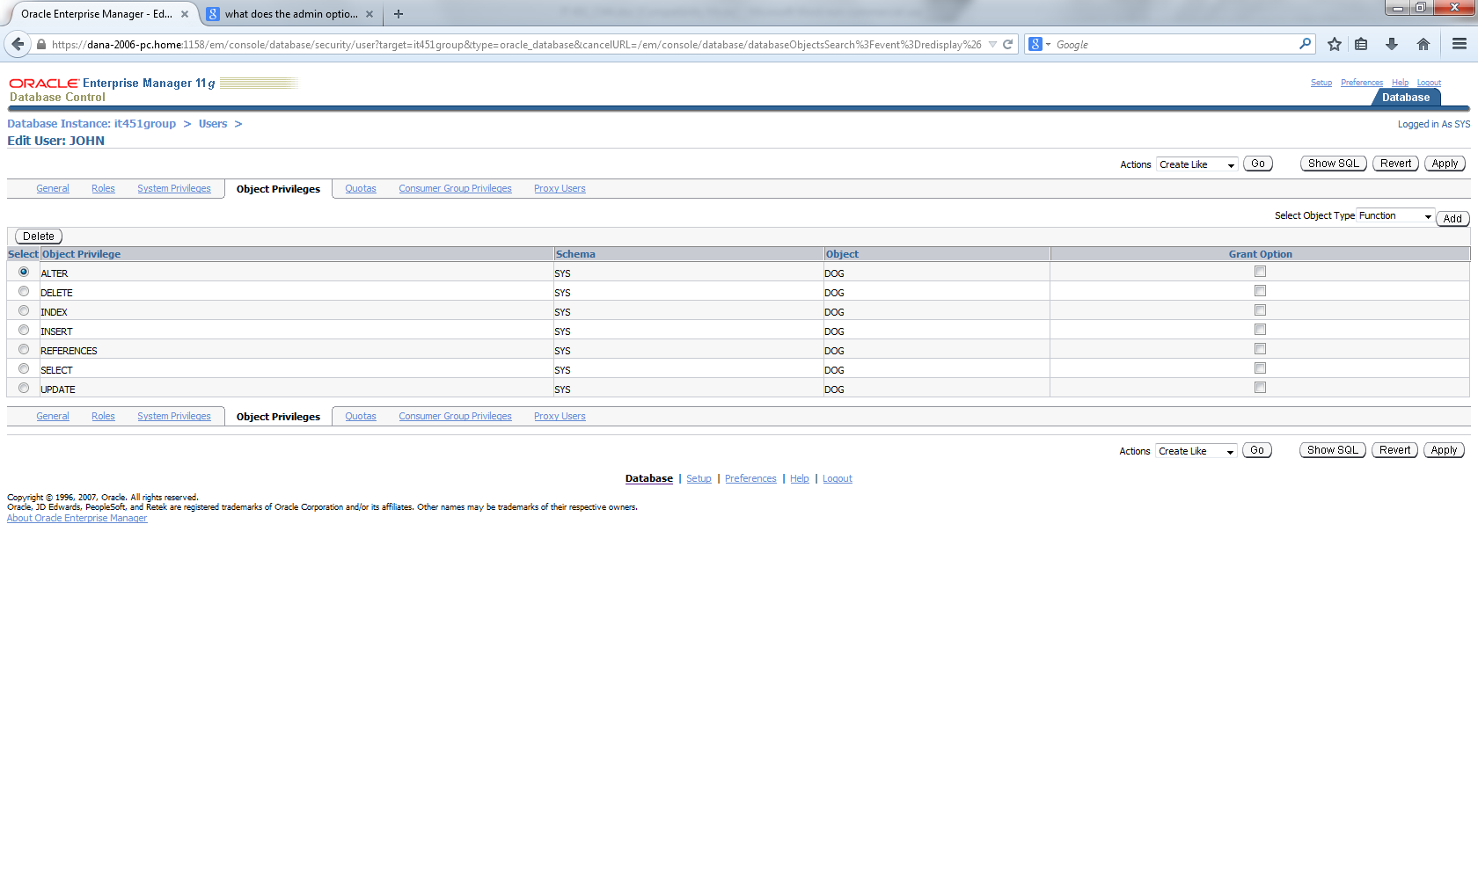

Created the object privilege DEBUG for user john on dog table through EM.
GRANT DEBUG ON dog TO john;

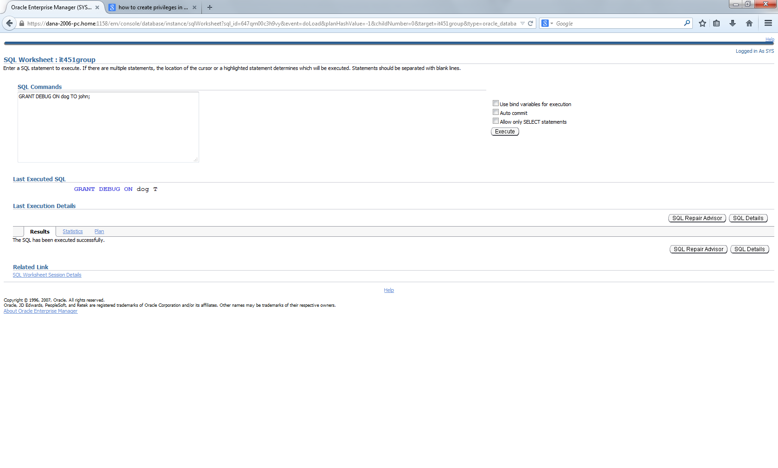

- Create and modify profiles

CREATE PROFILE jack LIMIT
FAILED_LOGIN_ATTEMPTS 5
PASSWORD_LOCK_TIME 5/1440;

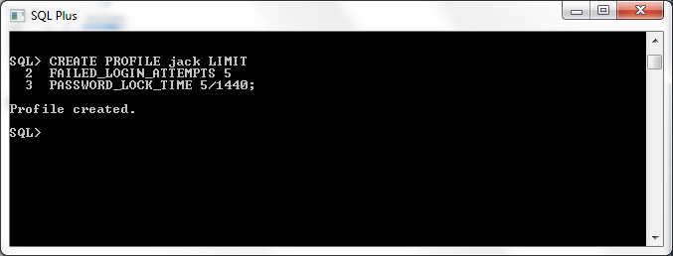

We created the profile jack and allowed it to have 5 failed log in attempts and a 5 minute timer after the fifth failed attempt.

ALTER PROFILE jack LIMIT FAILED_LOGIN_ATTEMPTS UNLIMITED;

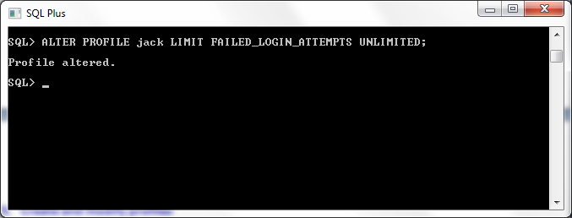
This statement removes the failed login attempts restriction. The user can enter their password as many times as they need to without getting locked out.

Used this statement to enable certain resource limit restrictions.

ALTER SYSTEM SET resource_limit = TRUE SCOPE = BOTH;

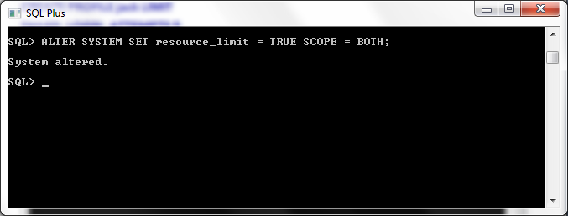

CONNECT_TIME is the resource we chose to manipulate:

CREATE PROFILE jill LIMIT CONNECT_TIME 10;
We created the profile jill and limited her connection time to 10 minutes.

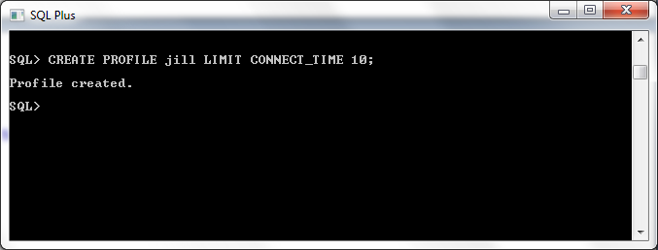

ALTER PROFILE jill LIMIT CONNECT_TIME UNLIMITED;
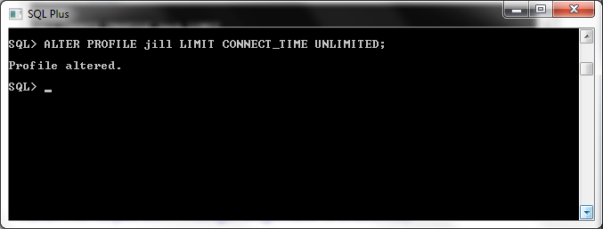
We altered jill’s profile connection time to unlimited.

- Enable and disable auditing

AUDIT table BY john;
This turns on the audit feature for tables on john’s account.
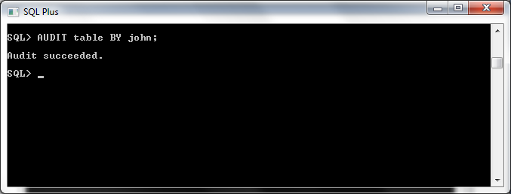

NOAUDIT table BY john;
This disables the audit feature for tables on john’s account.
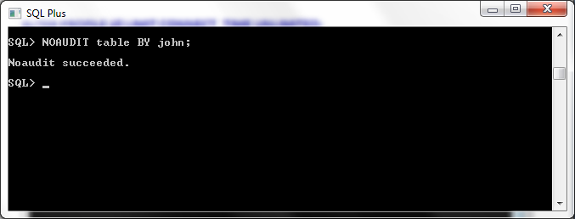
- Review contents of AUD$

DESC sys.aud$;
Lists all fields in the table sys.AUD$.

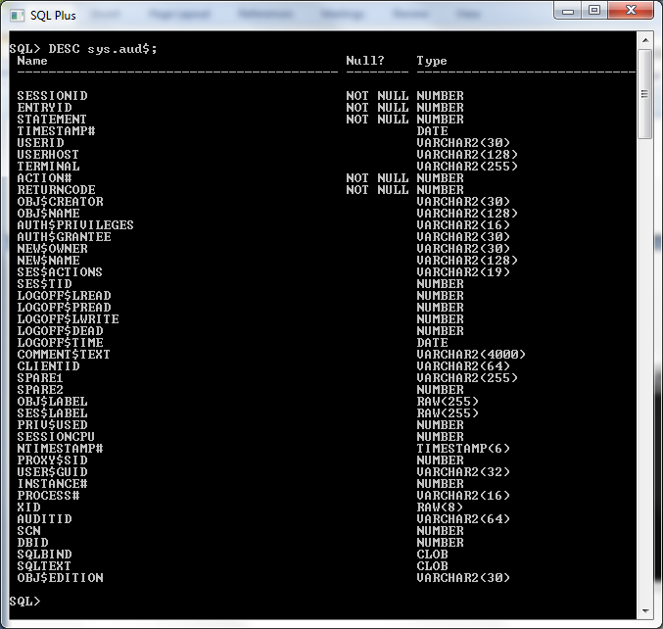

We ran the statement SELECT * FROM sys.aud$ and it kept executing for several minutes so we were unable to get a screenshot. We assume that it was a log of everything we did and is long for that reason. We decided to query the sessionid from the aud$ and it returned the following results:

SELECT sessionid FROM sys.aud$;

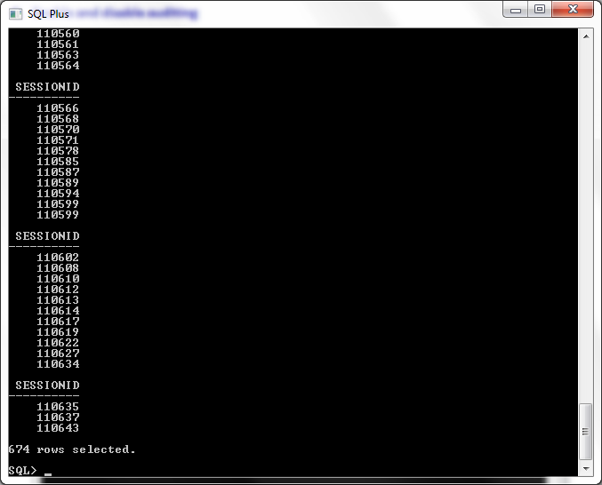

Screenshot of the Audit Settings Page on EM

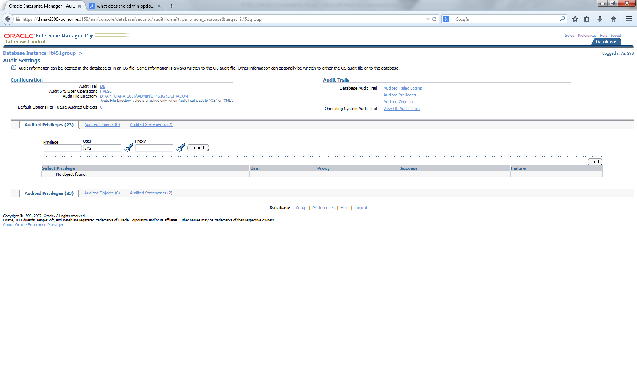

- Review contents of DBA_AUDIT% views

We decided to look at what the users in the database had audit options enabled on them. We just turned on table and session for john and then showed the results.

SELECT audit_option, user_name
FROM dba_stmt_audit_opts
ORDER BY audit_option, user_name;

